UI/UX Design Document

# Project: Using existing CCTV networks for crowd management,crime prevention and work monitoring for Railway Stations.

#### Team: Meta Minds

#### Date: January 24, 2024

## **User Research Insights**

* Users want a clear and concise overview of the anomalies and the details along with the detection of on-spot overcrowd alerts.
* Users desire interactive visualizations/graphical data to explore crowd trends and any anomalies over time or at any particular instants of time.
* Users want the right allocation of waiting rooms,parking lots for effective crowd management.
* Users appreciate proactive feedback for actions to be taken by the station on-ground authorities based on management insights.
* Users express concerns about data privacy and security.

**User Personas:**

* Station Manager: Oversees overall operations and security at the railway station.Needs real-time crowd monitoring to ensure passenger safety and would have to receive immediate alerts for potential security threats.
* Maintenance Staff: Conduct maintenance and repairs at the railway station.Has access to CCTV footage to identify and address maintenance issues.Integration with work schedules for streamlined operations.
* System Administrator: Manages and maintains the CCTV network and monitoring system.Looks after system health monitoring and alerts for potential risks and has the control over the configured CCTV networks in the railway stations.

**Wireframes and Mockups (Created in Figma)**

**Link to Figma File:** [Link](https://www.figma.com/file/3VCM3n3wAUalS4ow29D1vK/Nestria-Hackathon--Team-MetaMinds?type=design&node-id=0-1&mode=design&t=AeeFTBUzmEqBqYaJ-0)

**Key Screens:**

* Homepage: Displays the following relevant data:
  + Services offered
  + Feedback and contact
  + Frequent FAQs
* Crowd Monitoring : Displays the logs collected on the crowd count with interactive graphs and timely snapshots.
* Anomaly Detection: Collection of all the crime actions detected and an analysis on solved and unsolved cases.
* Dashboard: Collective data representation of prime factors to manage crowds and prevent crime incidents by analyzing collected logs and extracting insightful data.

***FIGMA IMAGES:***

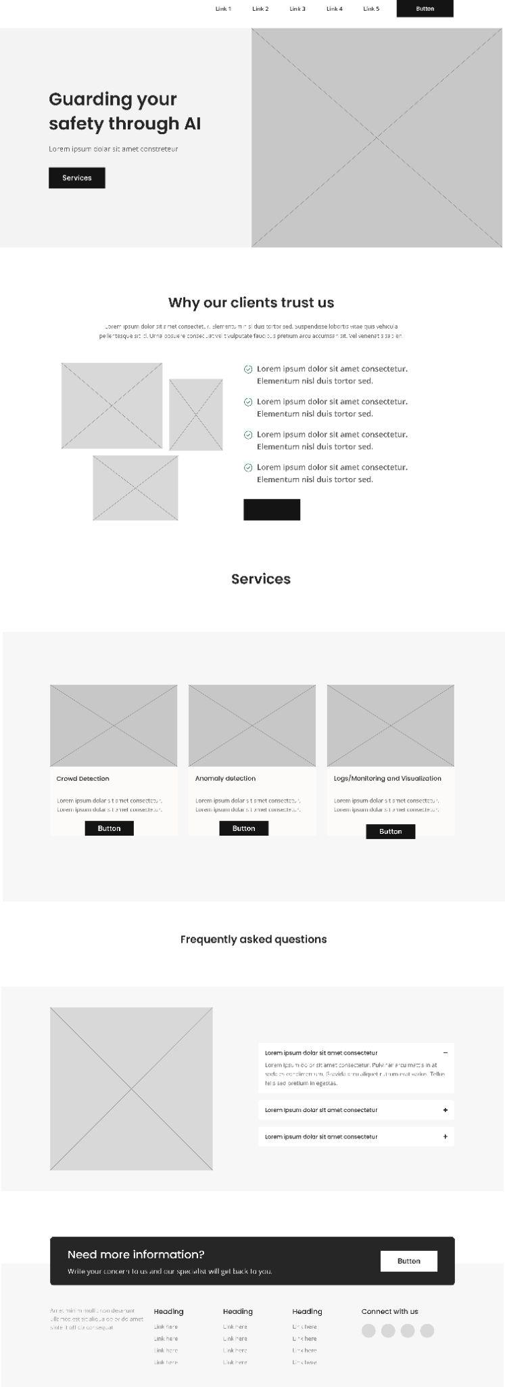



**User Flow Maps**

**Key User Flows:**

* Navigation to crowd detection for users to have access to the crowd snapshots after fixed time intervals and graphical analysis on the collected data.
* Navigation to Anomaly detection for access to the crime record logs, sorting of solved and unsolved cases and graphical evaluations on the collected data.
* Navigation to Dashboard for graphical insights from the rest of the service models for final analysis of methods of effective crowd management and crime prevention techniques by identification of the rush according to hourly basis and the locations with highest crime rates.

***USER FLOW MAP:***

